SOLAR POWER SYSTEM WITH DOUBLE AXIS SOLAR TRACKER USING ESP-32
PROJECT REPORT
Acknowledgement
I would like to express my sincere gratitude to all those who have contributed to the successful completion of this project. First and foremost, I am deeply thankful to my respected teachers and mentors for their constant guidance, valuable suggestions, and continuous encouragement throughout the development of this project. Their expert knowledge and insightful feedback helped me to understand the fundamental concepts of solar energy systems, embedded systems, and automation techniques in a clear and practical manner.
I would also like to extend my heartfelt thanks to my institution for providing me with the necessary resources, facilities, and a supportive environment to carry out this project effectively. The opportunity to work on such a practical and innovative project has greatly enhanced my technical skills and problem-solving abilities.
I am especially grateful to my friends and classmates who supported me during this journey. Their cooperation, discussions, and exchange of ideas played an important role in improving the quality of this project. They were always ready to help whenever I faced difficulties, which made the process much easier and more enjoyable.
I would like to sincerely thank my family for their unwavering support, motivation, and encouragement throughout this project. Their belief in me gave me the confidence to complete this work successfully. Without their emotional and moral support, this achievement would not have been possible.
Finally, I would like to thank everyone who directly or indirectly contributed to the completion of this project. This project has been a great learning experience, and I am grateful for all the support and guidance I received.

Abstract
This project presents the design and development of an advanced solar power generation system integrated with a dual-axis solar tracking mechanism using the ESP32 development module. The primary aim of this system is to enhance the efficiency of solar panels by ensuring maximum exposure to sunlight throughout the day and across different seasonal variations.
In conventional solar energy systems, solar panels are fixed at a particular angle, which limits their ability to capture sunlight efficiently as the sun moves across the sky. To overcome this limitation, the proposed system employs a dual-axis tracking mechanism that allows the solar panel to move both horizontally (azimuth) and vertically (elevation). This enables precise alignment of the panel with the sun’s position at any given time, significantly improving energy output.
The system uses an array of Light Dependent Resistors (LDRs) strategically placed to detect variations in light intensity from multiple directions. These sensors continuously monitor sunlight and send real-time data to the ESP32 microcontroller. Based on this input, the controller processes the difference in light intensity and generates appropriate control signals to drive motors or mechanisms. As a result, the solar panel is automatically adjusted to maintain an optimal angle for maximum solar radiation absorption.
The ESP32 development module plays a crucial role in this project due to its high processing capability, energy efficiency, and integrated Wi-Fi and Bluetooth features. These features not only ensure fast and reliable system performance but also open up possibilities for future enhancements such as remote monitoring, data logging, and IoT-based smart energy management systems.
Furthermore, this system is designed to be cost-effective, scalable, and easy to implement, making it suitable for both small-scale and large-scale applications. The use of automated tracking reduces human intervention and increases reliability, while also contributing to better utilization of renewable energy resources.
In conclusion, this project demonstrates an intelligent and automated approach to solar energy harvesting by combining embedded systems and renewable energy technologies. It highlights the importance of innovation in improving energy efficiency and supports the global transition towards sustainable and eco-friendly power solutions.

Introduction
In recent years, the demand for energy has increased rapidly due to population growth, industrialization, and technological advancements. Traditional sources of energy such as fossil fuels are depleting at an alarming rate and also contribute significantly to environmental pollution and global warming. As a result, there is a growing need to shift towards renewable and sustainable energy sources. Among these, solar energy is one of the most promising, abundant, and eco-friendly sources available.
Solar energy systems convert sunlight into electrical energy using photovoltaic (PV) panels. However, one of the major limitations of conventional solar panels is that they are fixed in position. Since the sun’s position changes continuously throughout the day and across seasons, fixed panels are unable to capture maximum sunlight at all times. This leads to reduced efficiency and lower power generation.
To overcome this limitation, solar tracking systems have been introduced. These systems automatically adjust the orientation of solar panels to follow the movement of the sun, ensuring that the panels receive maximum solar radiation throughout the day. Among different types of tracking systems, dual-axis solar trackers are the most efficient as they allow movement in both horizontal (east-west) and vertical (north-south) directions. This enables precise alignment with the sun’s position, resulting in significantly higher energy output compared to fixed and single-axis systems.
In this project, a dual-axis solar tracking system is designed and implemented using the ESP32 development module. The system utilizes Light Dependent Resistors (LDRs) to detect the intensity of sunlight from different directions. Based on the sensor inputs, the ESP32 processes the data and controls motors to adjust the position of the solar panel dynamically. The use of ESP32 provides advantages such as high processing speed, low power consumption, and built-in Wi-Fi and Bluetooth capabilities, making the system more efficient and adaptable for future smart applications.
This project not only improves the efficiency of solar energy systems but also demonstrates the integration of embedded systems with renewable energy technologies. It provides a cost-effective and automated solution that can be applied in real-world scenarios such as solar farms, street lighting, and smart energy systems.
Overall, the development of a dual-axis solar tracker represents an important step towards maximizing the utilization of solar energy and promoting sustainable development. It highlights the role of modern technology in addressing energy challenges and contributes to the advancement of clean and green energy solutions.

Circuit Diagram
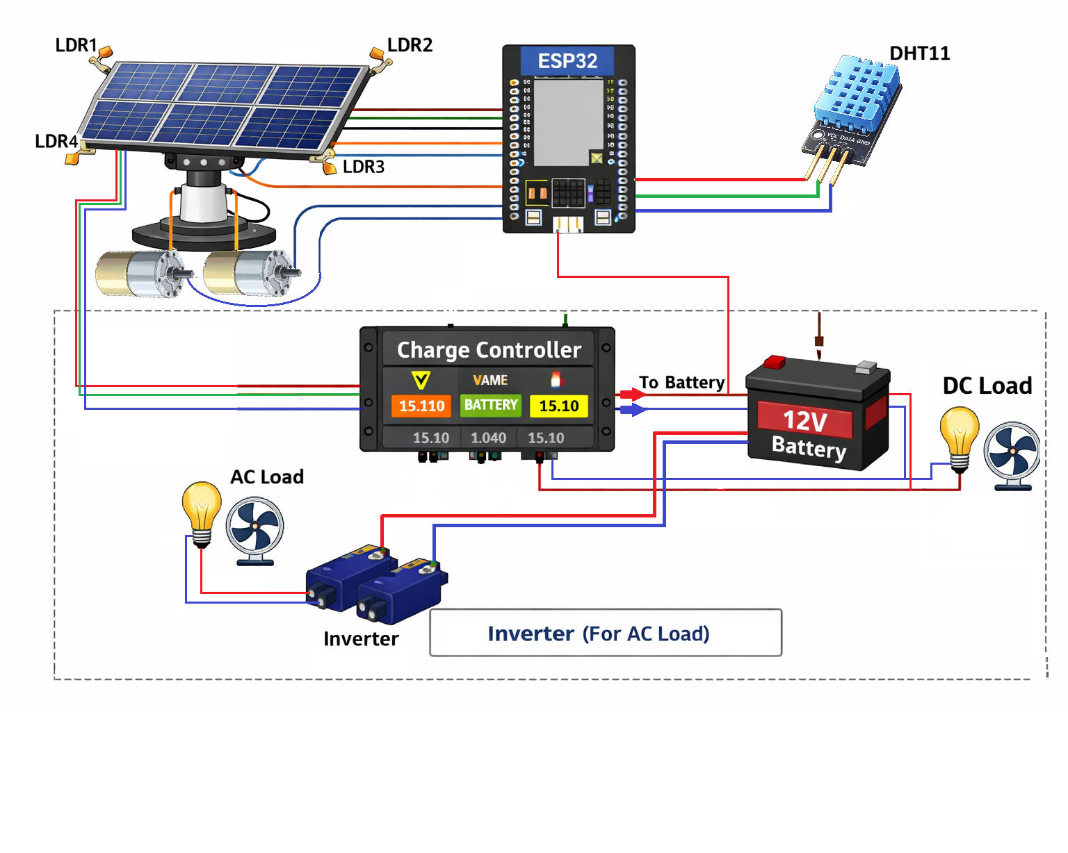

Fig : Solar power system with double axis solar trcker using ESP-3
Components used
- Solar Panel: Converts sunlight into electrical energy.
- ESP-32: Microcontroller used for processing sensor data and controlling the system.
- LDR Sensors: Detect light intensity from different directions
- DC Motor: Rotates the panel based on control signals.
- Battery: Stores energy.
- Charge Controller: Protects battery from overcharging.
- Inverter: Converts DC to AC.
- DHT11 : Temperature sensor used to know outside temperature.

- ESP-32 Micro Controller
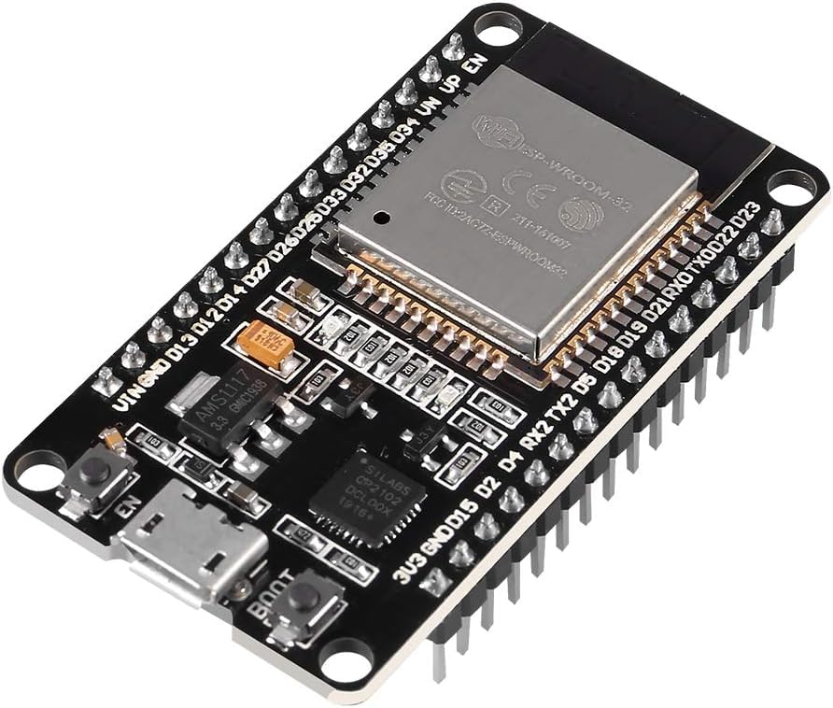
The ESP32 is a highly integrated and energy-efficient microcontroller developed by Espressif Systems, designed specifically for modern embedded and Internet of Things (IoT) applications. It combines high processing capability with built-in wireless communication features such as Wi-Fi and Bluetooth, making it an ideal choice for smart and connected systems. The microcontroller is powered by a dual-core Tensilica LX6 processor, which can operate at a clock frequency of up to 240 MHz, enabling it to handle complex computations and multitasking efficiently.
From a technical standpoint, the ESP32 operates at a voltage of 3.3V and supports a wide range of input/output interfaces, including digital GPIO pins, analog-to-digital converters (ADC), digital-to-analog converters (DAC), UART, SPI, and I2C communication protocols. It typically includes 4MB of flash memory, allowing sufficient storage for firmware and data processing. The built-in Wi-Fi (802.11 b/g/n) and Bluetooth (Classic and BLE) capabilities eliminate the need for additional communication modules, thereby reducing system complexity and cost.
In the context of the solar tracking system, the ESP32 serves as the central control unit. It continuously reads the analog signals from multiple LDR sensors, processes the data to determine the direction of maximum light intensity, and accordingly generates control signals to drive the DC motors. This ensures that the solar panel remains aligned with the sun throughout the day, thereby maximizing energy efficiency.
In general applications, the ESP32 is widely used in home automation systems, industrial monitoring, wearable devices, smart agriculture, and robotics. Its versatility, low cost, and powerful performance make it one of the most preferred microcontrollers in modern embedded system design.
Technical Specifications
- Microcontroller: Tensilica Xtensa LX6 (Dual-Core)
- Clock Frequency: Up to 240 MHz
- Operating Voltage: 3.0V – 3.6V (typically 3.3V)
- Flash Memory: 4MB (external)
- SRAM: ~520 KB
- Wi-Fi: 802.11 b/g/n
- Bluetooth: v4.2 (Classic + BLE)
- GPIO Pins: ~30–36
- ADC: 12-bit resolution (multiple channels)
- DAC: 2 channels (8-bit)
- Communication Protocols: UART, SPI, I2C, I2S, CAN
- Power Consumption: Ultra-low power modes available
General Applications of ESP32
- Internet of Things (IoT) systems
- Smart home automation
- Industrial automation and monitoring
- Smart agriculture systems
- Robotics and automation
- Solar Panel
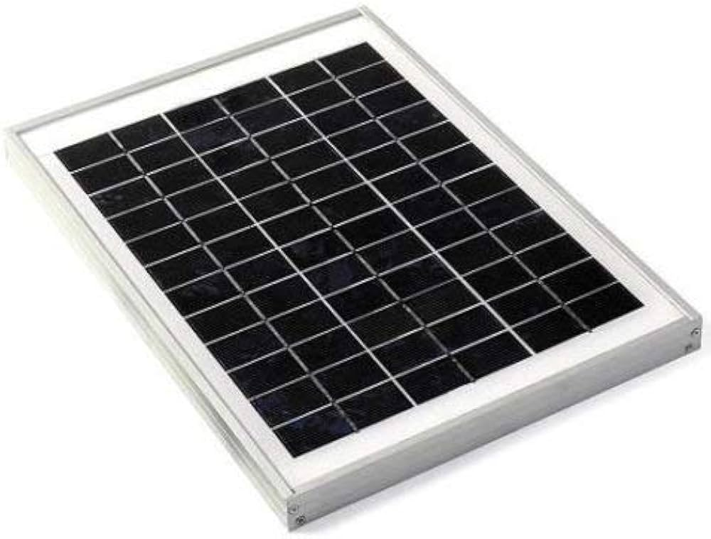

A solar panel, also known as a photovoltaic (PV) panel, is a device designed to convert sunlight directly into electrical energy through the photovoltaic effect. It consists of multiple interconnected solar cells made from semiconductor materials, typically silicon. When sunlight strikes the surface of these cells, photons transfer their energy to electrons, causing them to move and generate an electric current. This process enables the direct conversion of solar energy into usable electrical power without any moving parts, making it a clean and renewable energy source.
The 12V, 20W solar panel used in this project is a small-scale power generation unit suitable for low-power applications and experimental setups. It is designed to provide a nominal output voltage of approximately 12 volts under standard test conditions, with a maximum power output of 20 watts. The panel generally consists of either monocrystalline or polycrystalline silicon cells, with monocrystalline panels offering higher efficiency and better performance under low-light conditions.
From a technical perspective, the solar panel operates based on the principle of the photovoltaic effect, where the generated current is directly proportional to the intensity of incident sunlight. The output characteristics of the panel vary depending on environmental conditions such as solar irradiance, temperature, angle of incidence, and shading. Typically, the open-circuit voltage (Voc) of a 12V panel is around 18V–21V, while the operating voltage (Vmp) is approximately 17V. The current output is usually in the range of 1A to 1.2A for a 20W panel.
Technical Specifications
- Rated Power: 20 Watts
- Nominal Voltage: 12V
- Open Circuit Voltage (Voc): ~18V – 21V
- Maximum Power Voltage (Vmp): ~17V
- Maximum Power Current (Imp): ~1.1A – 1.2A
- Cell Type: Monocrystalline / Polycrystalline
- Efficiency: ~15% – 18%
- Operating Temperature Range: -40°C to +85°C
- Material: Tempered glass with aluminum frame
- Lifespan: 20–25 years
General Applications of 12V Solar Panels
- Small-scale solar power systems
- Battery charging systems
- Solar street lighting
- Portable solar devices
- Rural electrification
- Solar water pumping systems
- Mobile charging stations
- Light Dependent Resistor (LDR – 5mm)
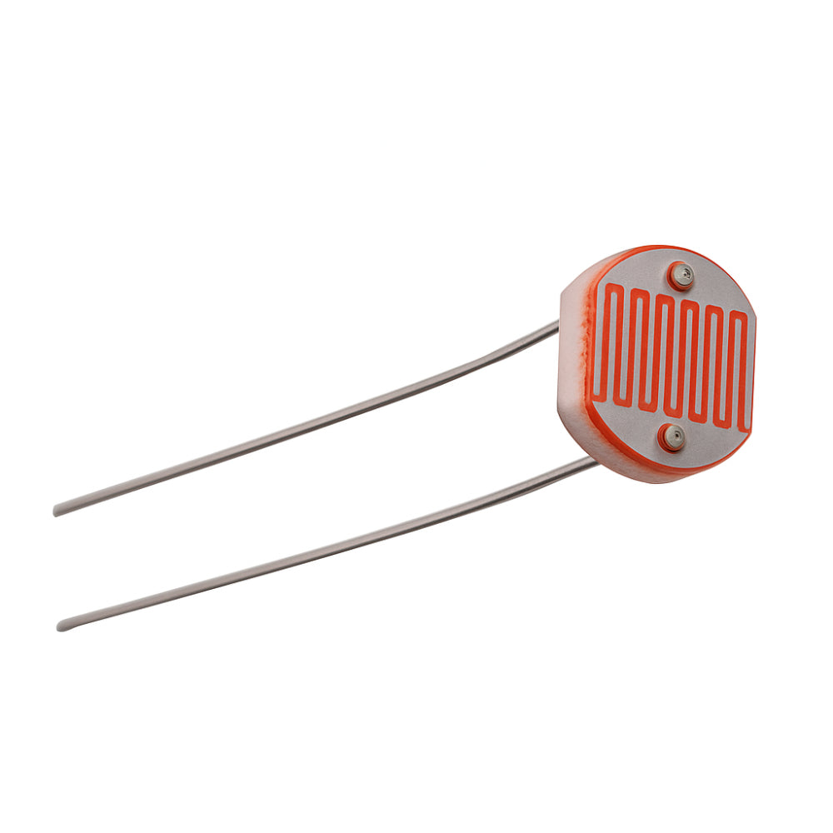
A Light Dependent Resistor (LDR), also known as a photoresistor, is a passive electronic component whose resistance varies in response to the intensity of incident light. The 5mm LDR refers to the physical size of the sensor head, which typically has a diameter of approximately 5 millimeters, making it compact and suitable for small-scale embedded applications. It is commonly manufactured using semiconductor materials such as cadmium sulfide (CdS), which exhibit photoconductive properties.
The working principle of an LDR is based on photoconductivity. When light photons strike the surface of the LDR, they transfer energy to electrons in the semiconductor material, causing an increase in charge carriers. This results in a decrease in resistance. In darkness or low-light conditions, the number of free electrons is minimal, leading to very high resistance. Thus, the resistance of an LDR is inversely proportional to the intensity of light falling on it.
From a technical standpoint, a 5mm LDR typically exhibits a resistance of several megaohms under dark conditions and a resistance of a few hundred ohms to a few kiloohms under bright light. It does not generate electrical energy by itself; instead, it is used in conjunction with other components, usually in a voltage divider configuration, to convert changes in resistance into corresponding voltage variations. These voltage signals can then be read by a microcontroller such as the ESP32 through its analog input pins.
Technical Specifications
- Sensor Type: Photoresistor (LDR)
- Size: 5mm diameter (sensor head)
- Material: Cadmium Sulfide (CdS)
- Operating Voltage: 3.3V – 5V (via circuit)
- Dark Resistance: 1 MΩ – 10 MΩ
- Light Resistance: ~100Ω – 10 kΩ
- Peak Spectral Response: ~540 nm (visible light)
- Response Time: 10 ms – 100 ms
- Power Consumption: Very low
- Operating Temperature: -30°C to +70°C
General Applications of LDR (5mm)
- Automatic street lighting systems
- Light intensity measurement devices
- Camera exposure control systems
- Solar tracking systems
- Fire and flame detection systems
- DC Motor (10 RPM)
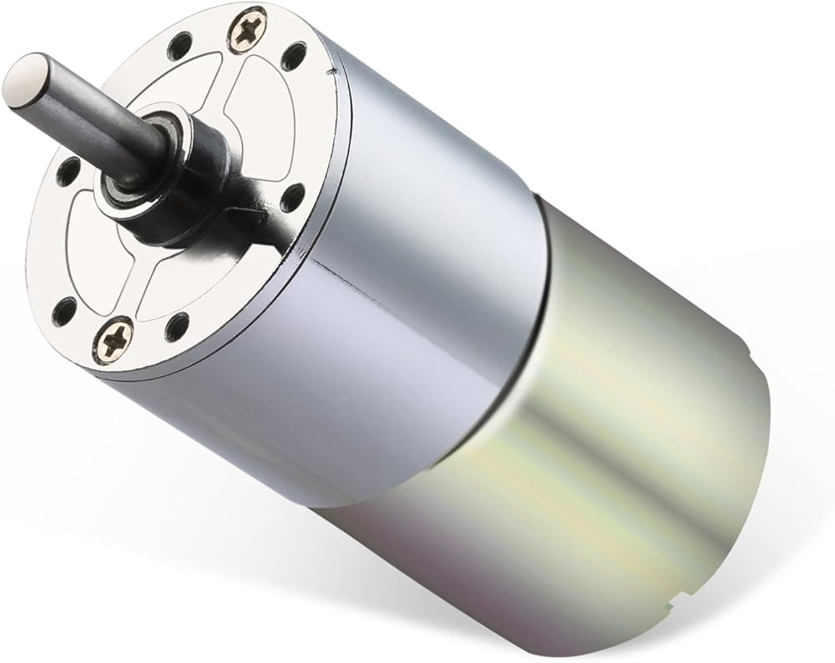
A DC motor is an electromechanical device that converts electrical energy into mechanical energy through the principle of electromagnetic interaction. The 10 RPM DC motor used in this project is typically a geared DC motor, which consists of a standard high-speed DC motor coupled with a reduction gearbox. This gearbox significantly reduces the rotational speed while simultaneously increasing the torque output, making it suitable for applications requiring slow and controlled movement.
The term “10 RPM” refers to the motor’s output shaft speed, indicating that the shaft completes approximately 10 revolutions per minute under rated conditions. Such low-speed motors are ideal for precision-based mechanical systems where gradual and stable motion is required. The internal gear arrangement, usually composed of metal or high-strength plastic gears, ensures efficient torque transmission and durability.
From a technical perspective, these motors generally operate within a voltage range of 6V to 12V DC, with 12V being the most common rating. The current consumption depends on load conditions, typically ranging from 100 mA to 500 mA under normal operation. Due to the gear reduction mechanism, the motor provides high torque, enabling it to move heavier loads compared to standard DC motors. The direction of rotation can be easily controlled by reversing the polarity of the supply voltage.
Technical Specifications
- Motor Type: DC Geared Motor
- Rated Speed: 10 RPM
- Operating Voltage: 6V – 12V DC
- Rated Voltage: 12V (typical)
- Torque: High torque (varies by model, ~5–15 kg·cm)
- Current Consumption: 100 mA – 500 mA
- Gearbox Type: Metal/Plastic reduction gears
- Shaft Type: D-type or round shaft
- Rotation: Bidirectional (CW & CCW)
- Efficiency: Moderate (depends on load and gear design)
General Applications of 10 RPM DC Motors
- Solar tracking systems
- Conveyor belt systems
- Robotics and automation
- Automatic doors and gates
- Industrial machinery
- Rotating display systems
- Agricultural equipment
- Gear-driven mechanical systems
- Slow-speed positioning systems
- DIY and educational projects

- Solar Charge Controller (12V, 10A)
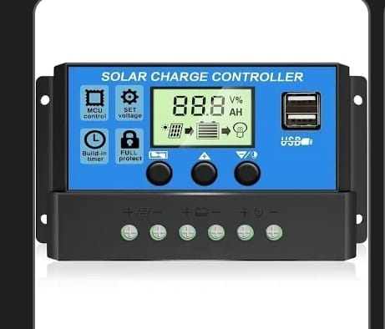
A solar charge controller is an essential electronic device used in photovoltaic (PV) systems to regulate the voltage and current flowing from the solar panel to the battery. Its primary function is to ensure that the battery is charged efficiently while preventing overcharging, over-discharging, and reverse current flow. The 12V, 10A solar charge controller is specifically designed for small to medium-scale solar systems, making it suitable for educational projects and low-power applications.
The controller operates by continuously monitoring the voltage level of the battery and adjusting the charging process accordingly. When the solar panel generates electricity, the charge controller regulates the output to maintain a safe charging voltage for the battery. Once the battery reaches its full charge, the controller either reduces or cuts off the charging current to prevent damage. Similarly, it disconnects the load when the battery voltage drops below a certain threshold, thereby protecting the battery from deep discharge.
Most 12V, 10A charge controllers are based on Pulse Width Modulation (PWM) technology, which efficiently controls the charging process by switching the current on and off at high frequency. Some advanced models use Maximum Power Point Tracking (MPPT) technology, which optimizes the power output from the solar panel by continuously adjusting the operating point. However, PWM controllers are more commonly used in small-scale systems due to their simplicity and cost-effectiveness.

Technical Specifications
- Rated Voltage: 12V DC
- Maximum Current: 10A
- Charging Technology: PWM (commonly)
- Input Voltage Range: ~15V – 25V (from solar panel)
- Output Voltage: Regulated 12V (battery charging)
- Battery Type Support: Lead-acid, AGM, Gel (some support Li-ion)
- Protection Features:
  - Overcharge protection
  - Over-discharge protection
  - Short-circuit protection
  - Reverse polarity protection
- Efficiency: ~70% – 90% (PWM type)
- Display: LED indicators or LCD (in some models)
- Operating Temperature: -10°C to +60°C
General Applications of Solar Charge Controller (12V, 10A)
- Solar home lighting systems
- Battery charging systems
- Off-grid solar power systems
- Solar street lighting
- Solar water pumping systems
- Small renewable energy setups
- Rural electrification
- Backup power systems
- Portable solar kits
- Camping and outdoor power systems
- Battery (12V, 12Ah)
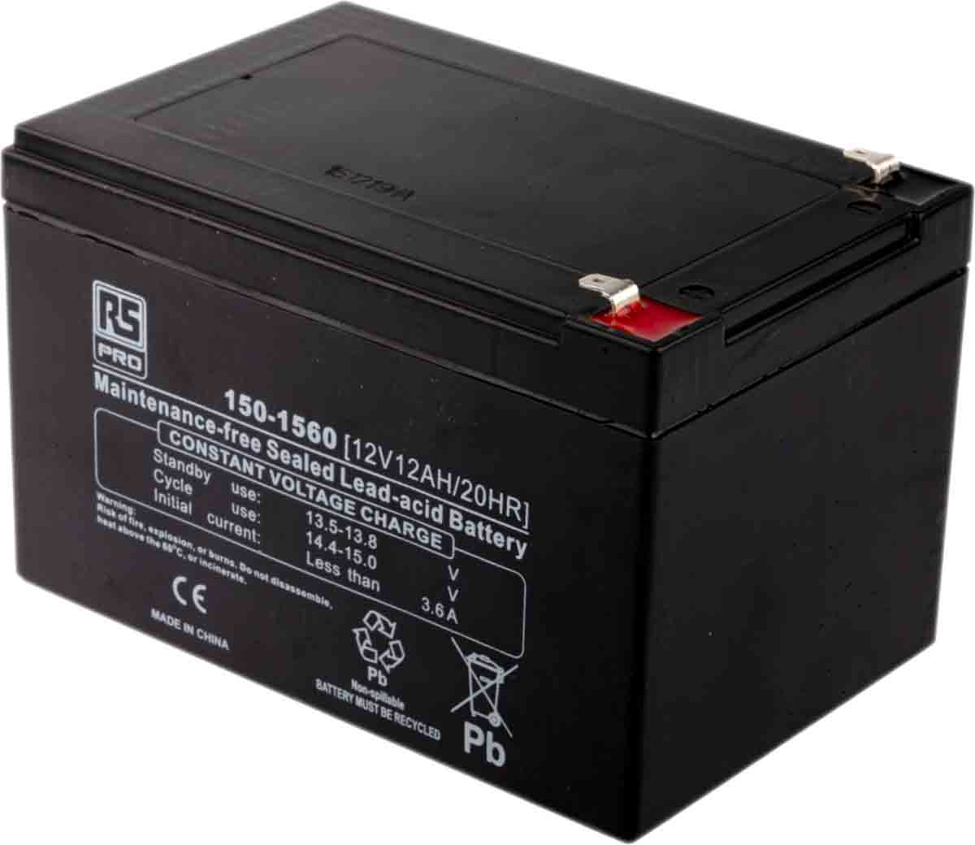
A 12V, 12Ah battery is a rechargeable energy storage device commonly used in small-scale power systems, backup applications, and renewable energy setups. It is typically a sealed lead-acid (SLA) battery, although other chemistries such as lithium-ion may also be used. In most solar-based projects, sealed lead-acid batteries are preferred due to their reliability, low cost, and ease of maintenance.
The battery is rated at 12 volts, which indicates its nominal output voltage, and 12 ampere-hours (Ah), which represents its storage capacity. The capacity rating means that the battery can theoretically supply a current of 12 amperes for one hour, or 1 ampere for 12 hours, under ideal conditions. This makes it suitable for powering low to medium power devices over extended periods.
The internal working of a lead-acid battery is based on electrochemical reactions between lead dioxide (PbO₂), sponge lead (Pb), and sulfuric acid (H₂SO₄) electrolyte. During discharge, chemical energy is converted into electrical energy, while during charging, the process is reversed. The sealed construction prevents leakage and reduces maintenance requirements, making it safe for indoor and portable applications.
Technical Specifications
- Battery Type: Sealed Lead Acid (SLA) / VRLA
- Nominal Voltage: 12V
- Capacity: 12Ah
- Charging Voltage: ~13.5V – 14.5V
- Discharge Cut-off Voltage: ~10.5V
- Maximum Charging Current: ~3A – 4A
- Internal Resistance: Low
- Efficiency: ~70% – 85%
- Lifespan: 3–5 years (depending on usage)
- Operating Temperature: -15°C to +50°C
- Maintenance: Maintenance-free (sealed type)
General Applications of 12V, 12Ah Battery
- Solar energy storage systems
- Uninterruptible Power Supplies (UPS)
- Emergency lighting systems
- Inverter systems
- Electric vehicles (small-scale)
- Security and alarm systems
- Telecommunications equipment
- Portable power systems
- Medical backup devices
- Camping and outdoor applications

- Uninterruptible Power Supply (UPS – 150W)

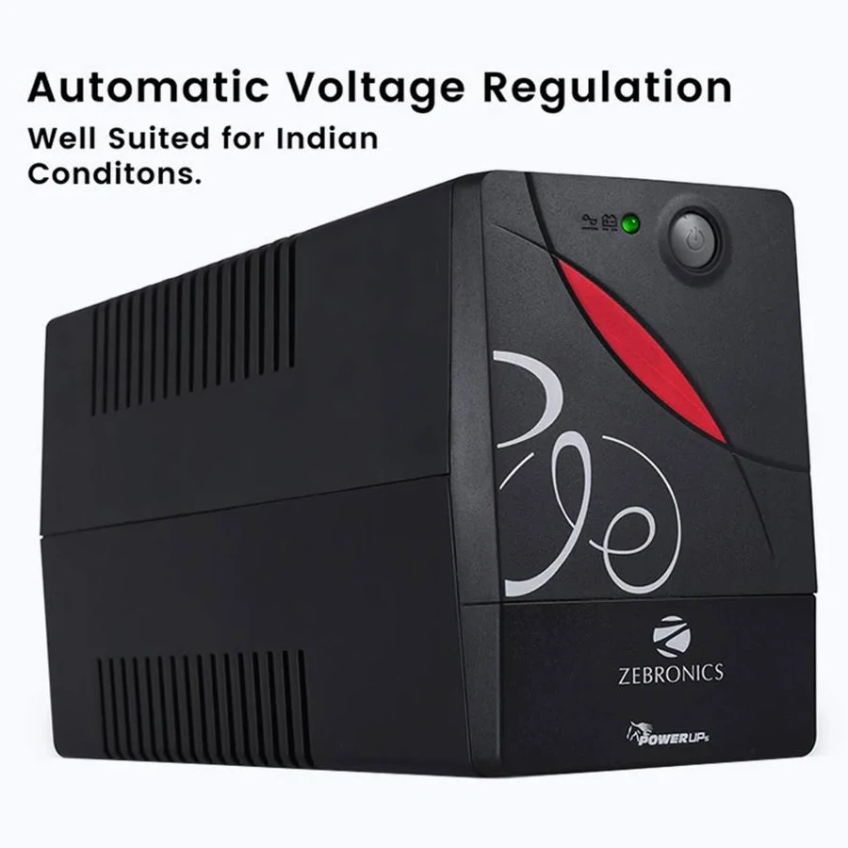
An Uninterruptible Power Supply (UPS) is an electrical device that provides emergency power to connected loads when the main power source fails or becomes unstable. A 150W UPS unit is a compact backup power system designed to supply low-power electrical devices with continuous and reliable power. It integrates multiple functional components such as a battery, inverter, charger, and control circuitry within a single unit.
The UPS operates by continuously charging its internal or external battery when the main power supply is available. During normal operation, it supplies power directly from the mains while simultaneously maintaining the battery charge. In the event of a power failure, the UPS instantly switches to battery mode and converts the stored DC energy into AC power using an internal inverter. This switching occurs within milliseconds, ensuring that connected devices experience no interruption.
A 150W UPS typically works with a 12V battery system and provides an output of 220V–240V AC at 50Hz. The system is designed to handle loads up to 150 watts, making it suitable for small electronic devices. It includes essential protection features such as overload protection, short-circuit protection, low battery cutoff, and thermal protection, ensuring safe and reliable operation.

Technical Specifications
- Power Rating: 150 Watts
- Input Voltage: 220V – 240V AC
- Output Voltage: 220V – 240V AC
- Output Frequency: 50 Hz
- Battery Type: 12V (internal or external)
- Backup Time: Depends on battery capacity (e.g., 12Ah battery)
- Transfer Time: 2 ms – 10 ms
- Charging Method: Automatic charging
- Efficiency: ~80% – 90%
- Protection Features:
  - Overload protection
  - Short-circuit protection
  - Low battery shutdown
  - Overcharge protection
- Cooling: Passive / fan-base
General Applications of 150W UPS
- Backup power for small electronic devices
- Computer and router backup systems
- Solar energy backup systems
- Emergency lighting systems
- Home automation systems
- Security and surveillance systems
- Medical equipment (low power)
- Telecommunication devices
- Portable power backup units
- Small office and home applications
- DHT11 Temperature and Humidity Sensor
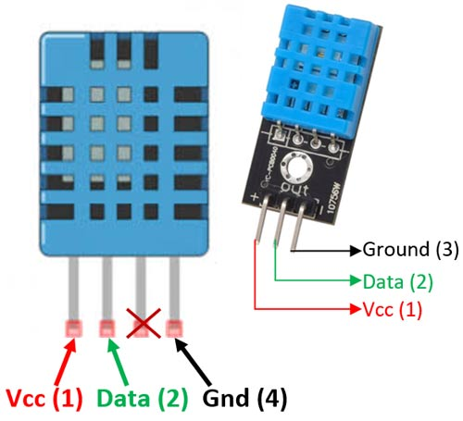
The DHT11 is a low-cost digital sensor designed to measure ambient temperature and relative humidity. It is widely used in embedded systems and IoT applications due to its simplicity, reliability, and ease of interfacing with microcontrollers. The sensor integrates a thermistor for temperature measurement and a capacitive humidity sensing element for detecting moisture levels in the air. These sensing components are combined with an internal microcontroller that processes the measured data and outputs it in a digital format.
The DHT11 operates based on the principle of resistance and capacitance variation. The thermistor changes its resistance with temperature, while the humidity sensor detects changes in capacitance caused by moisture in the air. The internal circuitry converts these analog variations into calibrated digital signals, which are transmitted to the microcontroller through a single-wire communication protocol. This makes it highly convenient to interface with controllers like the ESP32 without requiring complex analog-to-digital conversions.
Although the DHT11 is not as precise as higher-end sensors, it provides sufficient accuracy for general-purpose environmental monitoring. Its compact size and low power consumption make it ideal for small-scale projects and educational applications.
Technical Specifications
- Sensor Type: Digital Temperature and Humidity Sensor
- Operating Voltage: 3.3V – 5V
- Temperature Range: 0°C to 50°C
- Humidity Range: 20% to 90% RH
- Temperature Accuracy: ±2°C
- Humidity Accuracy: ±5% RH
- Output Signal: Digital (single-wire protocol)
- Sampling Rate: 1 reading per second
- Power Consumption: Very low
- Size: Compact module
General Applications of DHT11
- Weather monitoring systems
- Smart home automation
- HVAC systems
- Agricultural monitoring
- Environmental data logging
- IoT-based monitoring systems
- Greenhouse control systems
- Indoor air quality monitoring
- Educational projects
- Industrial basic monitoring systems

Algorithm
- Initialize ESP32(Node MCU-32S)
- Read LDR sensor values
- Compare left and right sensor value
- Rotate DC motor accordingly
- Repeat the process continuously

Working Principle
The proposed system is an advanced dual-axis solar tracking system integrated with a solar power management unit, controlled by the ESP32 microcontroller. The system is designed to maximize solar energy harvesting by continuously aligning the solar panel with the direction of maximum sunlight while efficiently managing the generated power for direct usage and storage.
The complete working of the system can be broadly divided into the following sections:
- Solar Tracking Mechanism
- Signal Processing using ESP32
- Motor Control System
- Solar Power Generation
- Charge Controller Operation
- Energy Storage in Battery
- Power Supply to Load (Direct and Backup)
- Optional Inverter Operation

1. Solar Tracking Mechanism
The solar tracking system is the core part of this project, responsible for ensuring that the solar panel always faces the direction of maximum sunlight. In this system, a dual-axis tracking mechanism is used, which allows movement of the panel in both horizontal and vertical directions.
To detect the direction of sunlight, four Light Dependent Resistors (LDRs) are used. These LDRs are placed at the four corners of the solar panel:
- LDR1 → Top Left Corner
- LDR2 → Top Right Corner
- LDR3 → Bottom Right Corner
- LDR4 → Bottom Left Corner
Each LDR changes its resistance based on the intensity of light falling on it. When the light intensity increases, the resistance of the LDR decreases, and when the light intensity decreases, the resistance increases. These variations are converted into voltage signals and sent to the ESP32.
The arrangement of four LDRs enables the system to detect the exact direction of sunlight imbalance. By comparing the light intensity from all four sides, the system determines whether the panel needs to move left, right, up, or down.

2. Signal Processing using ESP32
The ESP32 microcontroller acts as the brain of the entire system. It continuously reads the analog signals from the LDR sensors through its ADC (Analog to Digital Converter) pins.
The following operations are performed by the ESP32:
- Reading analog values from all four LDRs
- Converting analog signals into digital values
- Comparing the intensity values
- Calculating the difference between opposite LDRs
- Making decisions for panel movement
Decision Logic
- If (LDR1 + LDR4) > (LDR2 + LDR3) → Move panel towards left
- If (LDR2 + LDR3) > (LDR1 + LDR4) → Move panel towards right
- If (LDR1 + LDR2) > (LDR3 + LDR4) → Tilt panel upward
- If (LDR3 + LDR4) > (LDR1 + LDR2) → Tilt panel downward
To avoid unnecessary movements due to small variations (noise), a threshold value is used. Only when the difference exceeds this threshold, the panel moves.

3. DC Motor Control System
The movement of the solar panel is achieved using two DC motors, which are connected below the panel structure.
- DC Motor 1 → Controls horizontal movement (East-West)
- DC Motor 2 → Controls vertical movement (North-South)
The ESP32 generates PWM (Pulse Width Modulation) signals to control the angle of rotation of the DCs.
Working:
- Based on LDR comparison, ESP32 sends PWM signals
- DC rotates to a specific angle
- Panel position changes accordingly
- System continuously adjusts in real-time
DC motors are preferred because they provide:
- Precise angular control
- Smooth operation
- Low power consumption
Thus, the solar panel continuously tracks the sun’s movement from sunrise to sunset.

4. Solar Power Generation
Once the panel is aligned properly, it receives maximum sunlight. The solar panel converts this sunlight into electrical energy using photovoltaic effect.
Photovoltaic Effect:
When sunlight falls on the solar cells:
- Photons excite electrons
- Free electrons generate electric current
- Output is in the form of DC voltage
The efficiency of power generation is significantly increased because the panel is always optimally aligned with the sun.

5. Charge Controller Operation
The output from the solar panel is directly connected to a charge controller, which is a critical component in the system.
Functions of Charge Controller:
- Regulates voltage and current
- Prevents overcharging of battery
- Prevents deep discharge
- Protects system components
- Ensures stable power supply
The charge controller acts as an intermediate unit between the solar panel, battery, and load.

6. Energy Storage in Battery
The charge controller is connected to a 12V battery, which stores excess energy generated by the solar panel.
Working:
- When solar generation is high → battery charges
- Stored energy is used when sunlight is not available
The battery plays a crucial role in:
- Ensuring power availability at night
- Providing backup during cloudy conditions

7. Power Supply to Load
The system is designed to supply power to the load in two ways, ensuring uninterrupted operation.

Path 1: Direct Supply from Charge Controller
- Solar Panel → Charge Controller → Load
During daytime:
- Load receives power directly from solar energy
- Reduces dependency on battery
- Improves overall efficiency

Path 2: Battery Backup Supply
- Battery → Load
During night or low sunlight:
- Battery supplies stored energy to the load
- Ensures continuous operation

Combined Advantage
- Continuous power supply
- Efficient energy utilization
- Reduced energy loss

8. Optional Inverter Operation
An inverter is optionally connected to the battery for converting DC power into AC power.
Working:
- Battery provides DC supply
- Inverter converts DC → AC
- AC appliances can be powered
Applications:
- Fans
- TVs
- Household devices
If only DC loads are used, the inverter is not required.

9. Overall System Operation
The entire system works in a synchronized manner as follows:
- LDR sensors detect sunlight intensity
- ESP32 processes sensor data
- DC motors adjust panel direction
- Solar panel generates maximum power
- Charge controller regulates power
- Energy is:
  - Supplied directly to load
  - Stored in battery
- Battery provides backup when needed
- Inverter converts power if AC is required

Conclusion of Working Mechanism
The designed system efficiently combines solar tracking technology with intelligent power management. By using a dual-axis tracking mechanism, the system ensures maximum solar energy capture, while the integration of battery storage and direct load supply guarantees uninterrupted power availability.
This makes the system highly efficient, reliable, and suitable for real-world renewable energy applications.

Advantages & Applications
Advantages:
- Improves efficiency by 20–30%
- Automatic operation
- Low manual intervention
Applications:
- Home solar systems
- Agriculture water pumps
- Street lighting systems

Future Scope
The proposed dual-axis solar tracking system using the ESP32 microcontroller has significant potential for further development and real-world implementation. In the future, this system can be enhanced by integrating Internet of Things (IoT) technology, enabling real-time monitoring and control of important parameters such as solar panel output, battery status, and load consumption through mobile or web applications. The use of advanced techniques like Maximum Power Point Tracking (MPPT) can further improve the efficiency of the system by extracting maximum possible power from the solar panel under varying environmental conditions.
In addition, the accuracy of the tracking system can be improved by replacing LDR sensors with more advanced sensors or GPS-based solar positioning systems, which provide more precise alignment with the sun. The system can also be enhanced by incorporating Artificial Intelligence (AI) and Machine Learning (ML) algorithms to predict sunlight patterns and optimize panel movement. This not only improves efficiency but also reduces unnecessary motor operation and power consumption, making the system smarter and more reliable.
Furthermore, mechanical and electrical improvements such as using durable, weather-resistant materials and advanced motor mechanisms can make the system suitable for large-scale applications. The integration of efficient energy storage solutions like lithium-ion batteries and smart battery management systems can enhance backup performance. The system can also be expanded into hybrid energy systems by combining solar energy with other renewable sources like wind power. With proper cost optimization and design improvements, this system can be widely implemented in solar power plants, agriculture, street lighting, and smart homes, contributing significantly to sustainable and eco-friendly energy solutions.

Conclusion
The dual-axis solar tracking system using the ESP32 microcontroller successfully demonstrates an efficient and automated method of maximizing solar energy utilization. By continuously adjusting the position of the solar panel based on real-time sunlight intensity detected through LDR sensors, the system ensures that the panel remains optimally aligned with the sun throughout the day. The use of DC motors enables precise and smooth movement in both horizontal and vertical directions, significantly improving the overall energy capture compared to fixed solar panels.
In addition to effective tracking, the system also incorporates a reliable power management setup using a charge controller, battery storage, and direct load connection. This arrangement ensures efficient distribution of generated power by supplying energy directly to the load during daytime while simultaneously storing excess energy in the battery for backup usage. The inclusion of a battery-to-load connection guarantees uninterrupted power supply even during low sunlight or nighttime conditions, making the system practical and dependable.
Overall, this project highlights the successful integration of renewable energy technology with embedded systems and automation. It provides a cost-effective, scalable, and energy-efficient solution that can be applied in real-world scenarios such as solar power plants, street lighting, and smart energy systems. The implementation of this system contributes to the promotion of sustainable energy practices and demonstrates the potential of modern technology in addressing global energy challenges.
References
- Espressif Systems, ESP32 Datasheet and Technical Reference Manual.
- Arduino Official Website, https://www.arduino.cc
- National Renewable Energy Laboratory (NREL), Solar Energy Basics, https://www.nrel.gov
- Electronics Tutorials, Basic Electronics and Sensor Working, https://www.electronics-tutorials.ws
- Rashid, M. H., Power Electronics: Circuits, Devices and Applications, Pearson Education.

